Oracle Lab 5: PL/SQL (1)
Assoc. Prof. Dr. Nguyen Thai Nghe
Refer to this link http://plsql-tutorial.com/ then make a report (StudentID-lab5.docx) including examples (StudentID-lab5.sql).
- Introduction to PL/SQL
- Anonymous Block
- PL/SQL Variables
- PL/SQL Constants
- PL/SQL Conditional Statements
- PL/SQL Iterative Statements
Try the following blocks
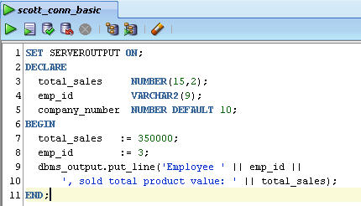

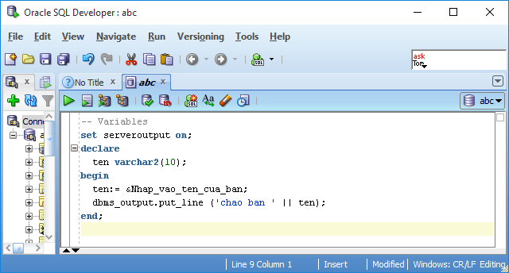

Install HR schema:
https://matthiashoys.wordpress.com/2020/07/09/installation-of-hr-sample-schema-on-free-oracle-atp-cloud-database/

